Introduction to Cloud Solutions Lab Report
Use this template to document your work as you complete the lab assignment in QA.
Your Information
Your Name: Nathanyll Brown
Lab Title: Creating AWS EC2 Instances Using Templates
Instructions
Follow the instructions to answer the questions related to the lab and add the required screenshots. Submit your completed report following the instructions in Canvas.
Section 1
1. Step 10: What do the YAML and JSON templates share in common?
Objects with keys, and values. These values can be other objects. Even in JSON or YAML the structure is the same: An object keyed or named "Resources" holds an object named "Instance." The Instance object holds two values. The first is a string "AWS::EC2::Instance" with the key "Type." The next is a blank object with the key "Properties." This basic EC2 instance parameter setup in template format stays consistent between the two styles because they are both using a similar structure of storage. Objects.
2. Step 10: How do the YAML and JSON templates differ from one another?
It comes down to syntax. JSON, or Javascript Object Notation, stores data in Javascript objects. Obviously, YAML does not do this, going for a more human readable approach that is indentation sensitive like Python syntax. Still, brackets were used to indicate the value of the key Properties was indeed a blank object and not a null value:
3. Step 14 Screenshot: YAML template with URL
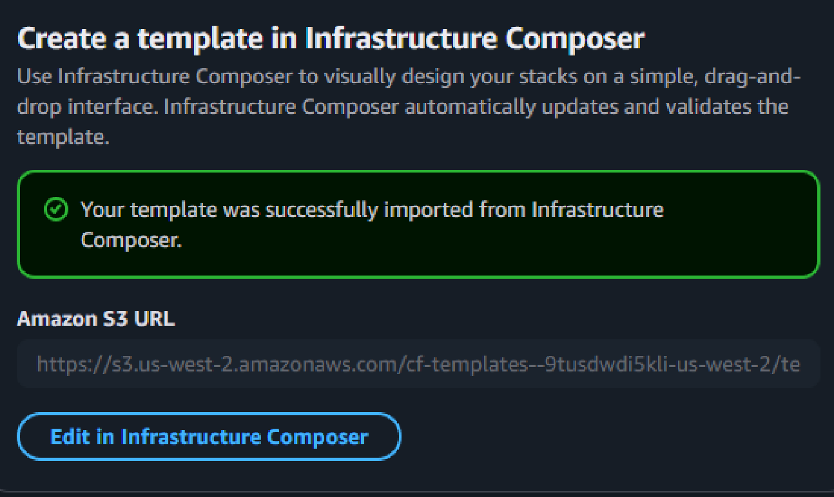

4. Step 30 screenshot: JSON template with URL
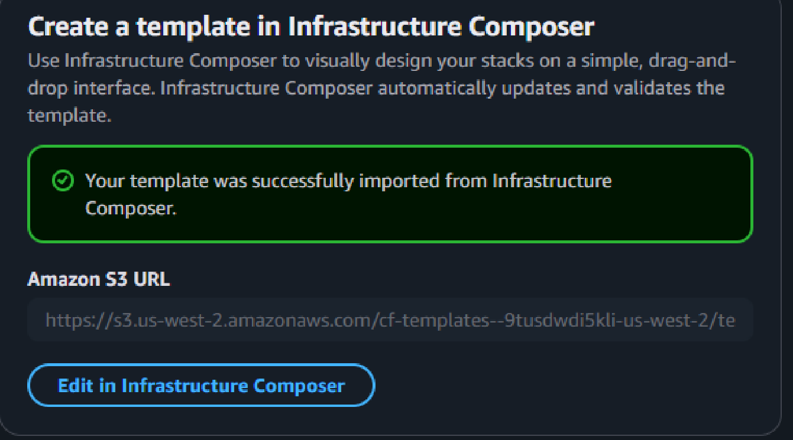

Section 2
5. Step 14: If you received a validation error, what steps did you take to resolve it?
Considering YAML is indentation sensitive, after including the correct parent objects keyed as "Resources" and "Instance" I was able to then notice that the "Properties" object was not formatted correctly. I placed my cursor at line five, at the key "AdditionalInfo" and then used the keybinds: CTRL + SHIFT + END. This shortcut allowed me to select everything that would need to be formatted into correct indentation underneath the "Properties" key. With my experience in VS Code, I used TAB on the selected text to indent the selection. Results came back, validation positive.

6. Step 14: What do validation errors indicate about the contents of template files?
The invalidated contents will not correctly translate over in the canvas viewer. As an example, if the "Properties" object is not given the parameters via the correction above, the value is automatically interpreted as "null" and the rogue parameters underneath the "Instance" object when they are supposed to be under the "Properties" object are thus ignored.

7. Step 17 screenshot: YAML template with URL
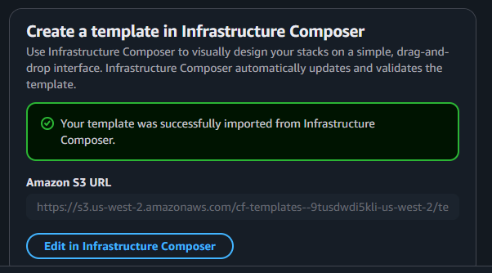

8. Step 28 screenshot: YAML template named stack (include your student ID)

